Based on the use cases derived from specifications and requirements, as well as the UML domain model obtained from those use cases during the first task of the first iteration, we can derive the following two system sequence diagrams (SSDs) representing the two operations *DeploySensor* and *ReadTemperature*, to show the interaction(s) between multiple components of the system when executing those operations.

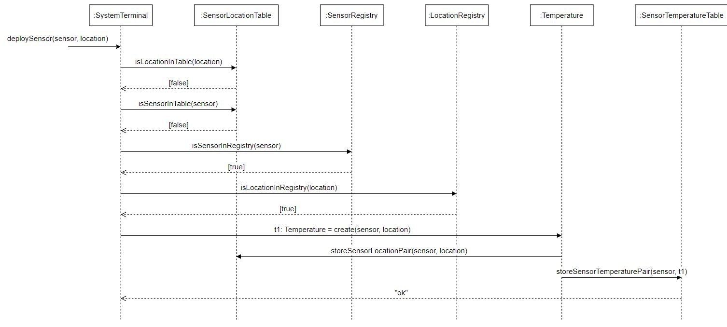SSD for *DeploySensor*:

Figure 1: SSD for DeploySensor

Figure 2: SSD for ReadTemperature

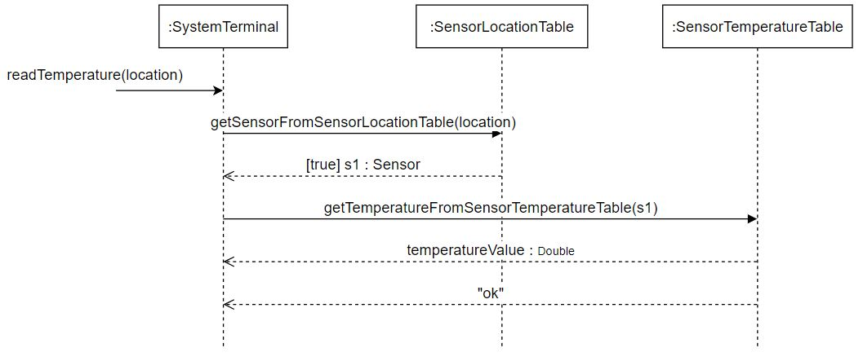SSD for *ReadTemperature*:

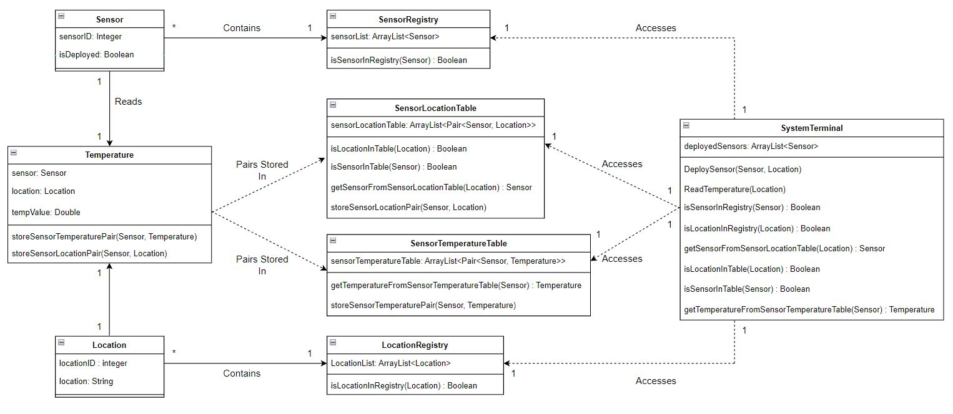From our domain model from Iteration 1, as well as our System Sequence Diagrams for the two operations *DeploySensor* and *ReadTemperature*, we have derived a UML Class Diagram for our system:

Figure 3: UML Class Diagram